**Compiler Design Lab 1 and Lab 2**

**Screenshots**

**Name**: Vishwa Mehul Mehta

**SRN**: PES2UG20CS389

**Section**: F

**Date**: 24-01-2023

Lab1:

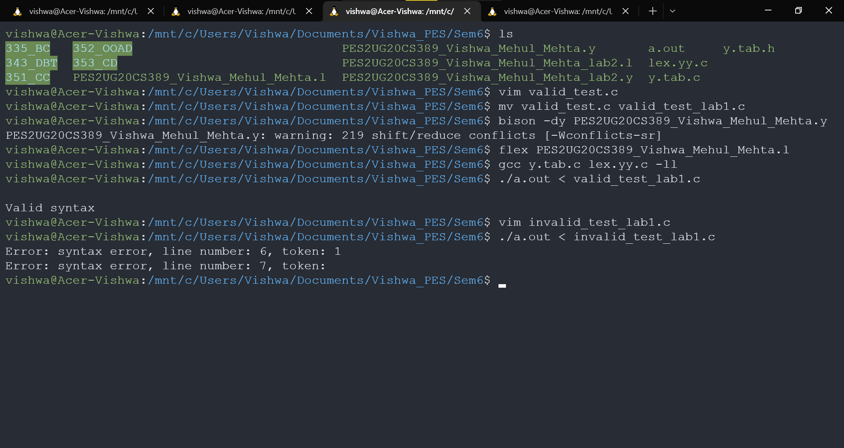

Lab2:

